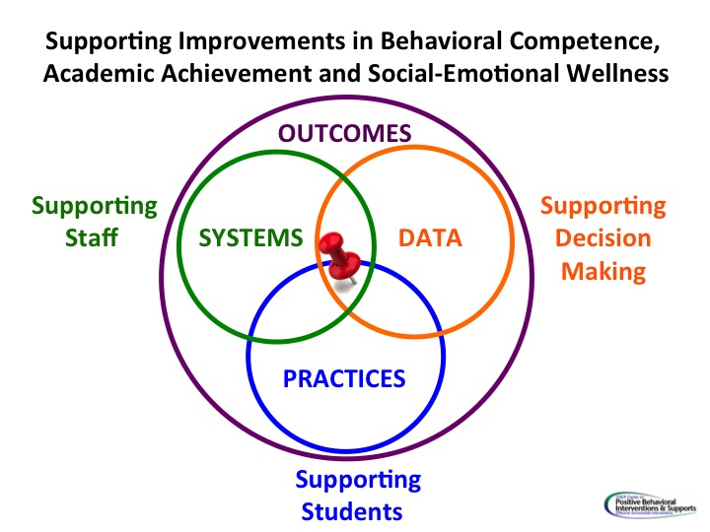
Data Informed Decision Making

Data that Indicates a Need

What data answers questions you have about student outcomes related to academics and/or behavior? What data speaks to a division priority? What data speaks to outcomes that you would like to change? First, consider division data trends.
Then, consider how the pilot school compares to those trends. Please list the data points below.

What is the story your data is telling about your students? Be precise! Describe who, what, when, where and why! The more precise the story, the more efficient and effective we can be in our decision-making!
Again please tell the story through the lens of both division and pilot school data.

Outcomes: How do we want to change this data? What do we want to see happen? Set a goal!
Pilot School(s): How will you access and share current data around progress towards outcomes? With division team? With faculty? Hint: think about the action plan for developing successful data systems. Are there related actions? Quick wins? |  |  | Division Team: How will you support the school(s) in accessing and sharing data with faculty? With the division? Hint: think about the action plan for developing successful data systems. Are there related actions? Quick wins?
Actions | By whom? | By when? | Actions | By whom? | By when?
Practices: What is a key practice that the school(s) will commit to implementing with fidelity? Name and define it.

Actions | By whom? | By when?
Systems: How will the division support the school in the implementation of new practices?

Actions | By whom? | By when?

Data: How will fidelity be measured? Did we do what we said we would do? Did we do it how we said we would? How are we going to progress monitor? Are we making changes to the data we hoped to change?
Actions | By whom? | By when?

